Let’s look a little deeper at CSS syntax and inheritance. Remember, CSS rules govern how the content of the element should be displayed. Here is a CSS rule-set.

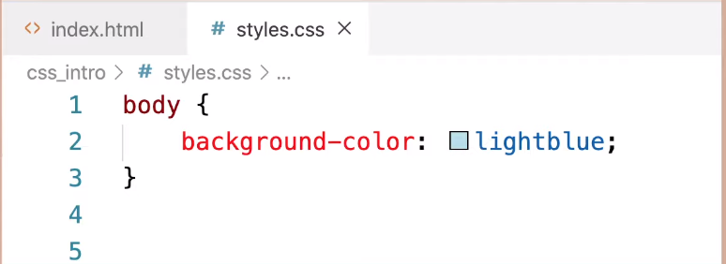

It has body as the selector (it’s the element or portion of our page being selected to have the rule applied to). Between the curly braces are all the declarations or property/value pairs that will apply the rules to the body. Here we have one declaration stating that the background color will have the value light blue. Background-color is the property name and lightblue is the value that is being assigned to the background color. THE BACKGROUND WILL THEN BE LIGHTBLUE. Each declaration has a colon in between the property name and the value and will end in a semicolon.

Let’s look at how we can apply more than one rule to an HTML page.



This time in addition to the light blue background on the body we can see there is even more CSS. The title is centered and blue and the link looks more like a button. The paragraph text is a little bigger and the image is sized better for the page. And there are a few other changes as well.

This is the external CSS file that has all the rules or rule sets that is affecting that page.

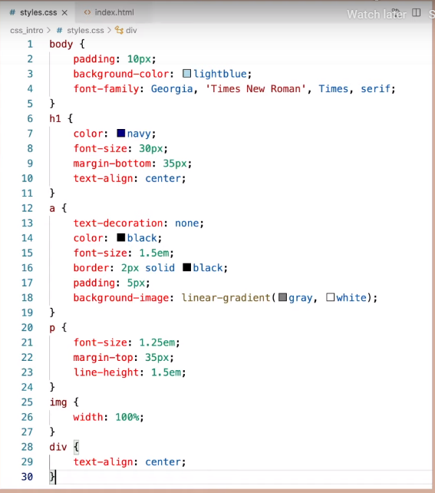

The body selector now has a few more declarations within its curly braces. We’ve given the whole body some padding or space around it and changed the font for our page. The h1 is the selector in the next rule-set. It has 4 declarations within its curly braces so just the h1 has a different font color, has a little margin space on the bottom, and is centered. Notice all the property value pairs in each declaration. Color is the property and navy is the value, font-size is the property and 30px is the value and so on. Don’t worry if you don’t understand all the properties and values on this page. You don’t need to know them all yet. For example, we will learn more about units of measurement like px and em later and we’ll learn why some properties here like font-family and border have 3 values. But for now, just make note of the property names in red and the values for those properties that follow the colon. Also see how each declaration ends in a semi-colon to note the end of each declaration. And the curly braces show the set of declarations, or declaration block, that go with each selector.

With CSS it’s good to know that it is working with elements that have invisible boxes around them.

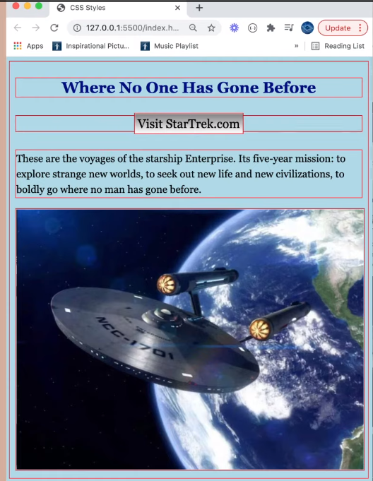

Here I have put a red border on every element on the page so you can see these boxes. CSS allows us to create rules that will control how these boxes and the content of the box are presented.

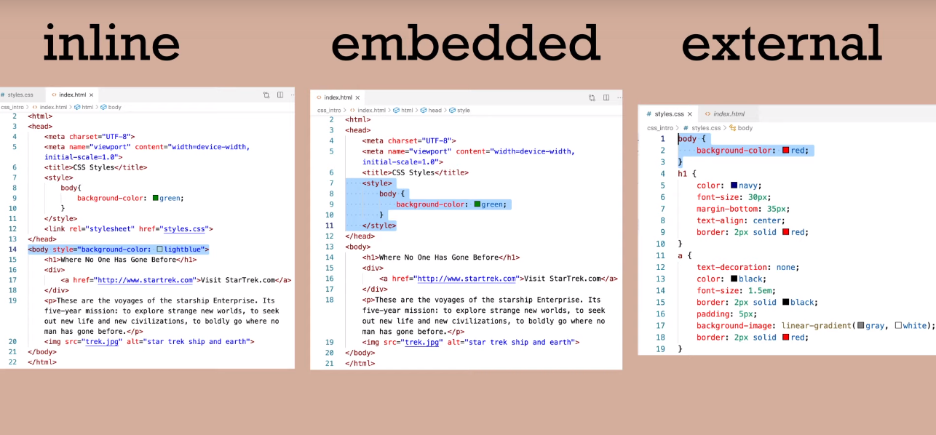Let’s look at precedence and inheritance with CSS rules. If there are two or more rules that apply to the same element it’s important to know which one will take precedence. For example, inline override embedded and embedded override external. like this:

We know however that **you should only use an external CSS file if possible** and not use inline and embedded.

But what if you also have the rules applied to the same element even within that external CSS file? Here the first rule set targets the body or has body as the selector, but later on line 20 body perhaps the developer forgot they already had a selector for body and they have used it again. Like this:

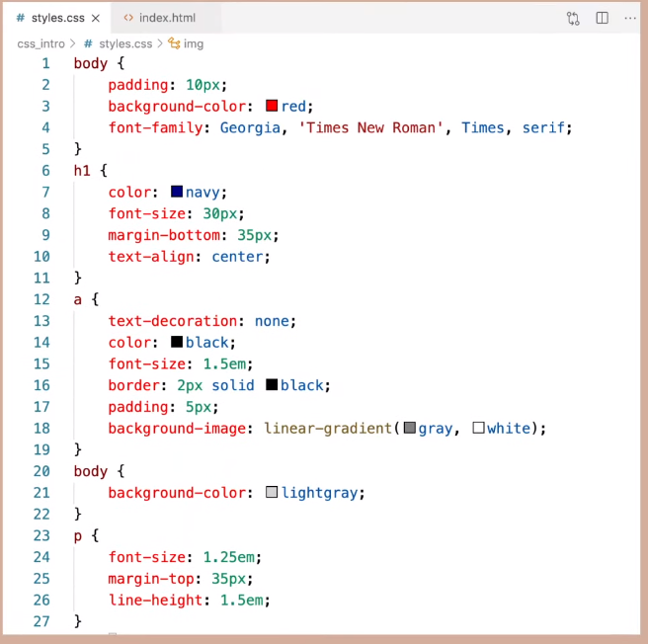

Both have a declaration of setting the background to different colors. **In this case the rule that comes later will take precedence and the background would be gray.** The first declaration of making the background red would be overridden. The second selector takes precedence.

Another important topic to understand is inheritance. Notice how the children elements of the body element, like the h1 or the paragraph will inherit some of the declarations applied to the parent element. For example both the h1 and the paragraph element have a light gray background and are styled with the Georgia font. Even though that was specifically declared in the body element rule-set. The children are inheriting those declarations. So there we have an introduction to syntax, precedence and inheritance of CSS.